**Ideation Phase**

**Define the Problem Statements**

|  |  |
| --- | --- |
| Date | 03 NOVEMBER 2022 |
| Team ID | PNT2022TMID08233 |
| Project Name | Project –AI based localization and classification of skin disease with erythema. |
| Maximum Marks | 2 Marks |

**Customer Problem Statement Template:**

Create a problem statement to understand your customer's point of view. The Customer Problem Statement template helps you focus on what matters to create experiences people will love. A well-articulated customer problem statement allows you and your team to find the ideal solution for the challenges your customers face. Throughout the process, you’ll also be able to empathize with your customers, which helps you better understand how they perceive your product or service.

PROBLEM STATEMENT

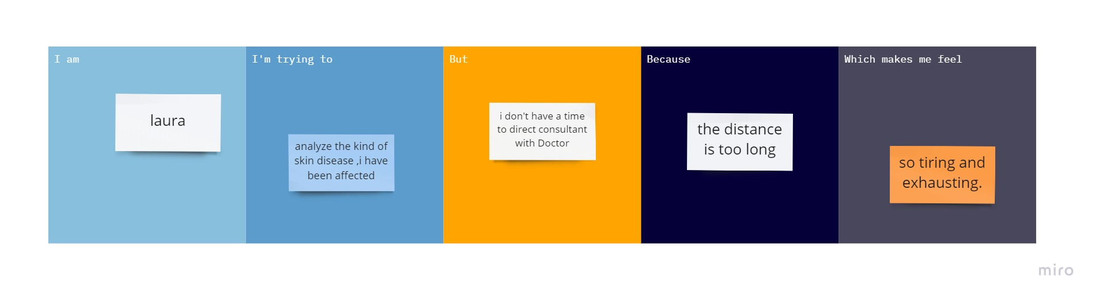

|  |  |  |  |  |  |
| --- | --- | --- | --- | --- | --- |
| **Problem Statement (PS)** | **I am (Customer)** | **I’m trying to** | **But** | **Because** | **Which makes me feel** |
| PS-1 | Joy | Know about the cause of skin which I have been affected | I don’t have the time to visit doctor | I am having a deadline on project work | stressed |
| PS-2 | Lisa | find the reason for itching in my scalp | I don’t want to go the hospital | For this simple analysis | uncomfortable to go the long distance. |
| PS-3 | Tom | Analyse the kind of skin disease | I don’t want to spend more money for this analysis | I am having less money | Depressed. |